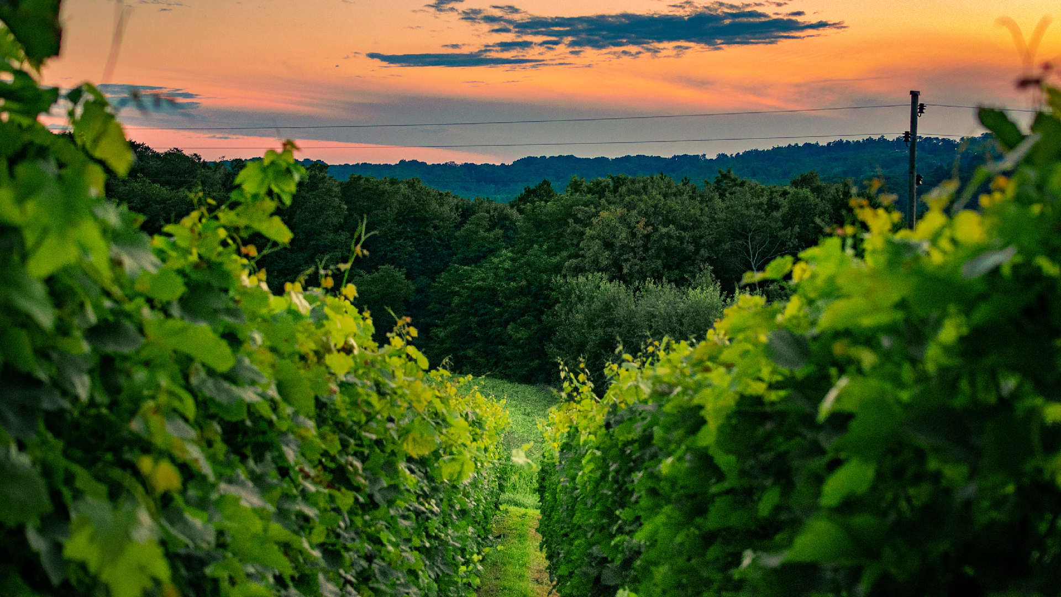
Destination management Zrin d.o.o. for services and travel agency
and travel agency

01

WINE ROUTE

KUTINA - VINOGRADSKA STREET
- KUTINSKA LIPA STREET - KUTINA

02

CYCLING ROUTE PLAN:

Gathering at 9:30 AM at Dr. Franjo Tuđman Square Departure for the tour at 10:00 AM
Lunch

We take you on a wine route tailor made for all lovers of cycling and the beautiful, picturesque area. The route includes a part of the Moslavačka wine road with beautiful views of the sunlit vineyards, as well as Kašner Winery, where you will get the opportunity to taste the best 4 types of wine on offer, including the indigenous Škrlet variety, as well as delicious local products. Whether you visit in spring, summer, or autumn, you will surely be amazed by the shades of colours this area creates, like a brush on a painting canvas.

The trail passes the baroque church of Saint Mary of the Snow, one of the most beautiful churches in the Sisak-Moslavina County, which you will see for yourself. Observation decks with beautiful vistas, traditional houses in Crkvena Street and a lunch in Moslavačka hiža will bring you back to grandma's kitchen and will open a door to the past; that warm, carefree, fragrant, and homely past from photos in old albums. Two wheels and a helmet: all you need to join us in the time machine this unique route creates.

