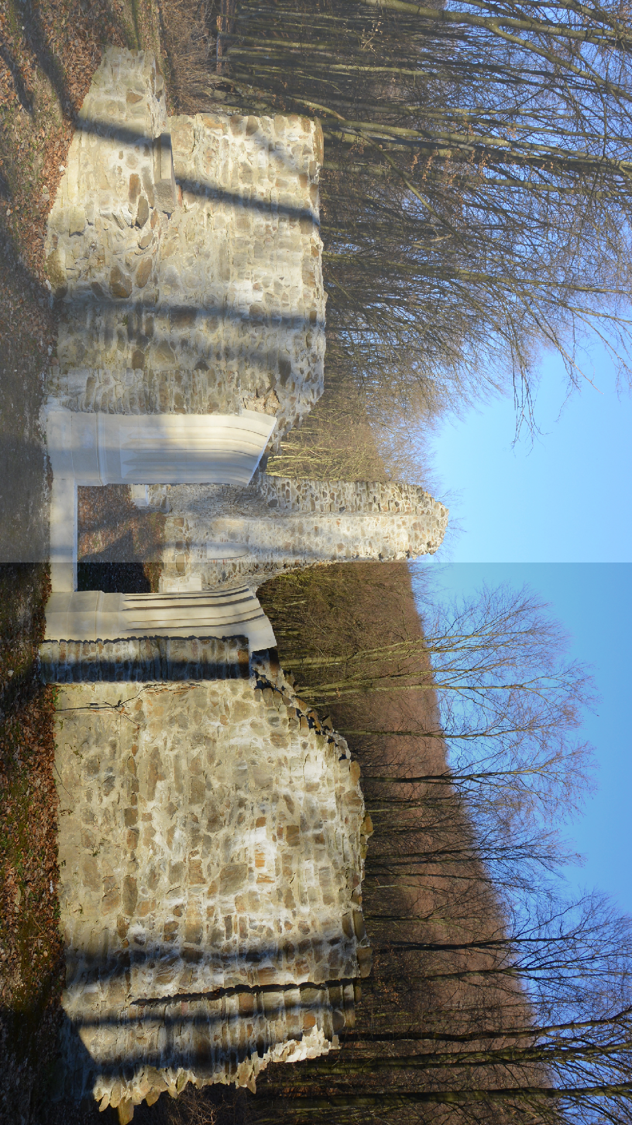
Destination management Zrin d.o.o. for services and travel agency
CYCLING ADVENTURE
"MOSLAVINA CHALLENGE"
01

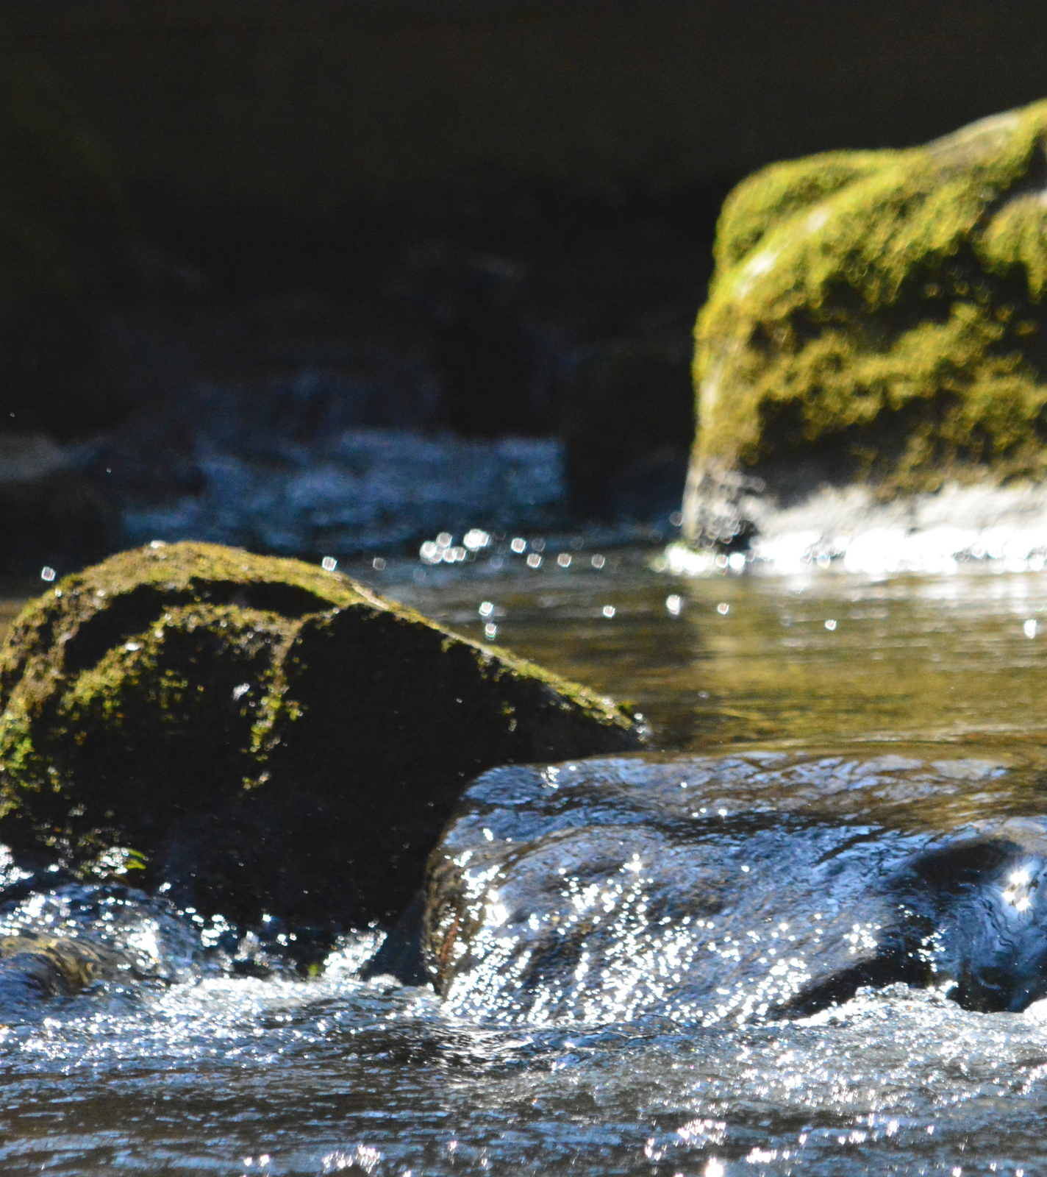
KUTINA - REPUŠNIČKA KLET
- MRAMOR HILL - CIGLENICA – MIKLEUŠKA - GARIĆ GRAD - PUKLI KAMEN - HUMKA - KUTINICA
- KUTINA
02

ITINERARY:

Gathering at 9:30 AM in Chestnut Park, Kutina Departure for the tour at 10:00 AM
Lunch

We take you on a circular cycling route through the beautiful landscape of the Moslavina region. From Kutina to the Moslavina wine road, an asphalt path leads to Mikša klet, where you will stop to taste 4 types of wine. A good snack goes with a good drink, after which you continue your journey to Mramor hill, an oil and gas site, through Ciglenica and Mikleuška all the way to the second, gravel section, which leads to a forest path next to the quarry. Next to the entrance of the quarry is the stream of St. Cristopher, the patron saint of passengers and drivers. The route continues to Lake Mikleuška and to Humka - the highest peak of Moslavačka gora, where you will get to roll up your sleeves and grill sausages. A delicious al fresco lunch in the beautiful countryside will be the perfect thing to cap off your experience of this distinctive area.

The entire ascent to Humka follows a stream with numerous small waterfalls which create a beautiful experience complemented by wildlife. Humka is followed by a descent down the beautiful landscape of Moslavačka gora. The descent passes the turn for Bela crkva, a Pauline monastery founded in the second half of the 13th century, the chapel of St. George the Martyr, through the villages of Katoličke Čaire, Kutinska Slatina, near the turnoff for Romić klet, where you'll get to taste 4 varieties of wine, followed by a return to Kutina.

