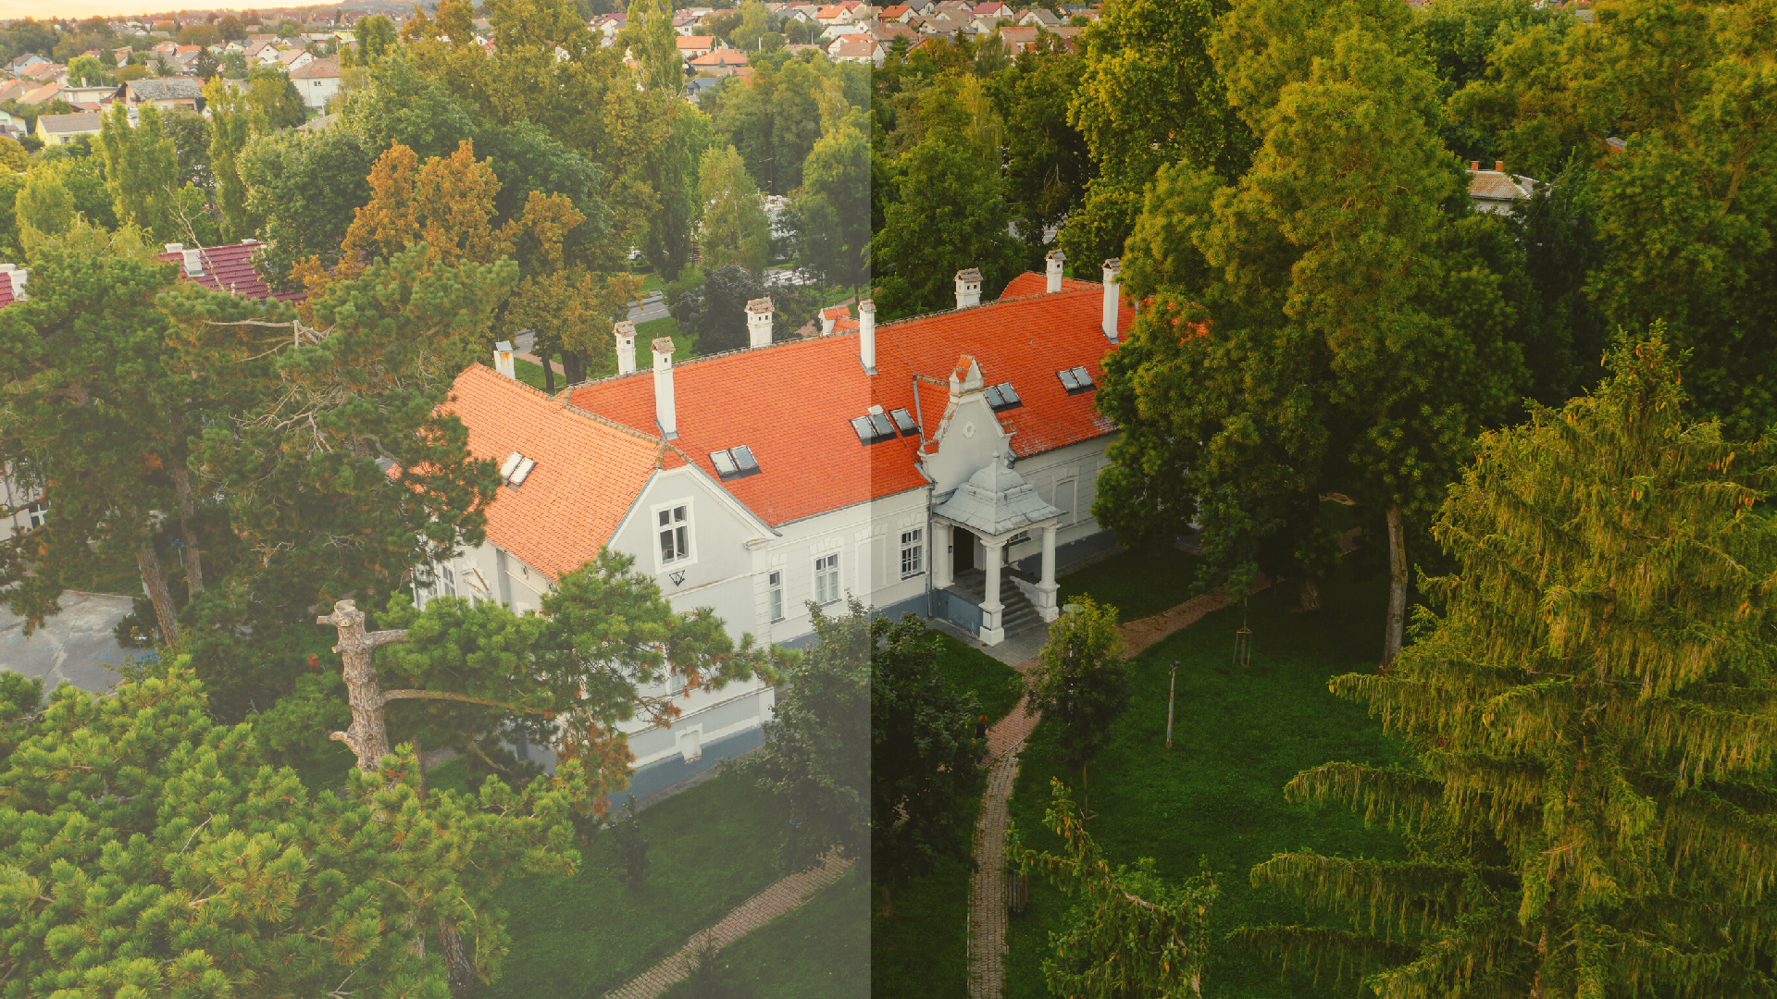
Destination management Zrin d.o.o. for services and travel agency
and travel agency

01

KUTINA IN THE EMBRACE OF LONJSKO POLJE AND TRSNO GORJE

DR. FRANJO
TUĐMAN SQUARE - MOSLAVINA MUSEUM - MOSLAVINA PORCHES - CHURCH OF ST. MARY OF THE SNOW - TURSKI STOL - MOSLAVAČKA HIŽA - GOLA MAJA - VINSKI DVOR

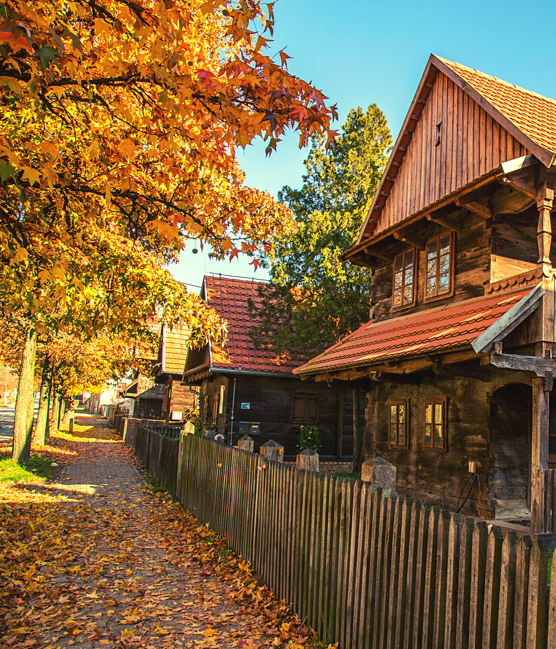
02
WALKING ROUTE ITINERARY:

Gathering at 8:30 AM at Dr. Franjo Tuđman Square
Start of the tour at 9:00 AM
Lunch at 1:30 PM

We take you on a walking tour from the heart of Kutina, Dr. Franjo Tuđman Square, where you will get an introduction to this unique city with a hot drink. We continue the tour in the direction of the Museum of Moslavina in Kutina, a rich gallery, cultural, historical, archeological and ethnographic exhibition, which boasts an ethnographic collection containing traditional clothing, jewelry, footwear, textiles, pottery, postcards, Easter eggs and many other details of the past life of this area; an excellent overture to Crkvena Street, where Moslavina’s famous porches are located. We combine a touch of tradition and the warmth of a home with one of the most beautiful churches in the Sisak-Moslavina region, the Church of St. Mary of the Snow, followed by a tour of the Turski stol educational trail.

Turski stol is a wonderful opportunity to breathe life into your lungs in a beautiful forest with ten instructive information points; “Panonski bazen”, “Visibaba”, “Luda gljiva”, “Lastin rep”, “Ekologija jelenko zemljokliz”, “Park šuma”, “Moslavačka gora” and “Voda”, an area carefully designed and created for a vacation within reach of the city center. After leaving the forest, we take you to a traditional lunch in Moslavačka hiža, followed by a walk to 'Gola Maja' where you will hear an interesting story about Auschovo. And, to complete the experience of the city of Kutina and Moslavina, we end our route in Vinski dvor, where you will taste 4 types of wine from the Moslavina region.

