Destination management Zrin d.o.o. for services and travel agency
01
KOŠĆEVA STAZA

REPUŠNICA RECEPTION CENTER (LONJSKO POLJE NATURE PARK) - NORTH RETENTION EMBANKMENT LONJSKO POLJE-
- VRBAČINEC -
-REPUŠNICA RECEPTION CENTER-

WALKING ROUTE ITINERARY:

Gathering at 9:00 AM in front of the Repušnica Reception Center Start of the tour at 9:30 AM
Lunch

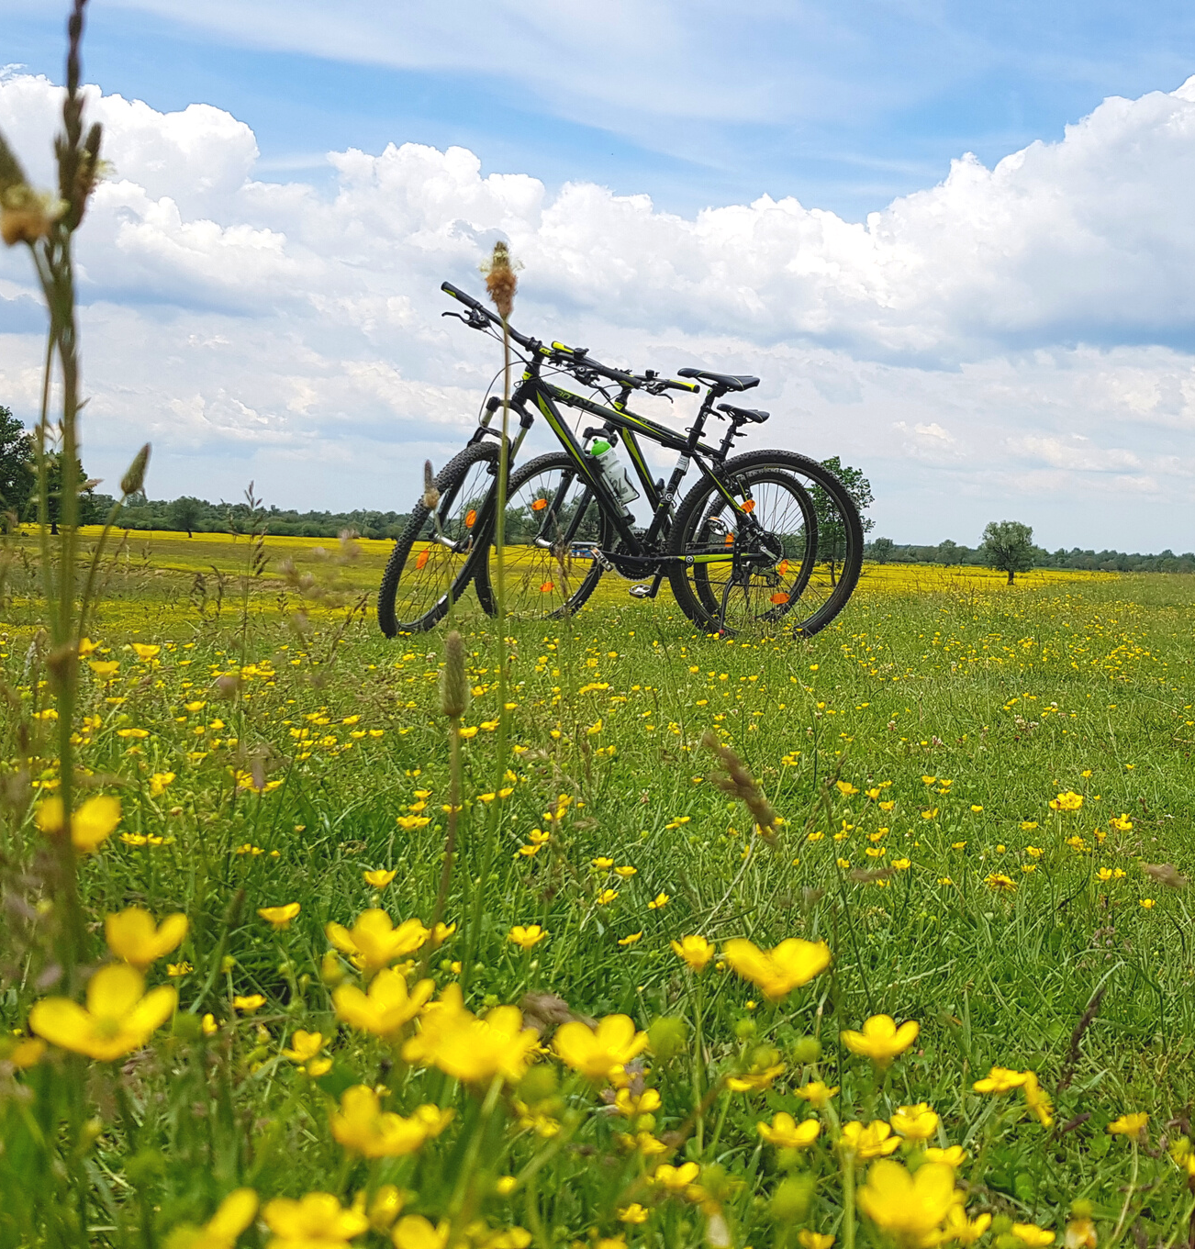

We take you to Košćeva staza through the beautiful Lonjsko polje in the area of Repušnica. The hiking trail is circular and suitable for families with children, and starts at the Repušnica Reception Center, goes along the northern embankment of the Lonjsko Polje retention area along the floodplains of meadows and pastures, across the Vrbačinec rest area and ends at the reception center. You can see native breeds grazing freely and watch birds on your own. For the little ones, we organize an educational workshop according to your wishes; The corn crake, a bird of the wet meadows, Posavina horse and amphibians, while for you we organize a cycling tour to the Jame canal, where you can try your hand at kayaking.

02

