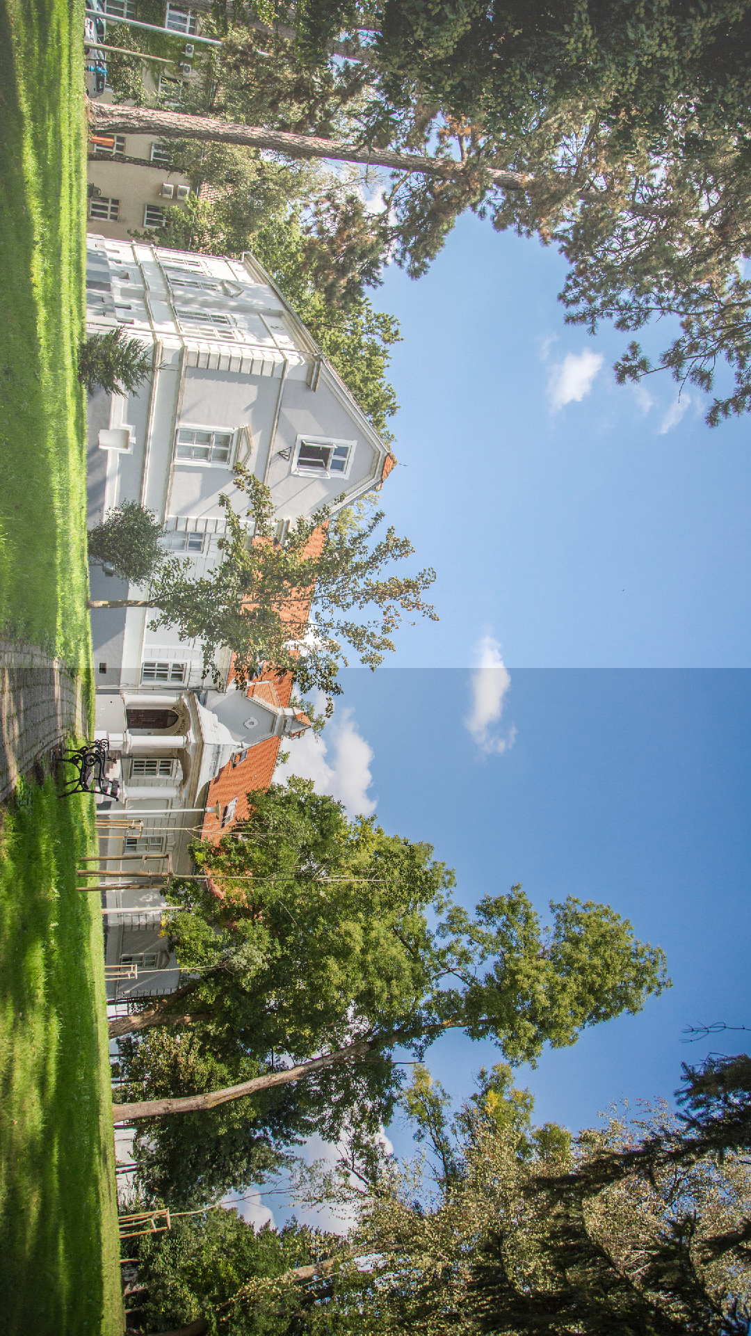
Destination management Zrin d.o.o. for services and travel agency
01
NATURE
ADVENTURE

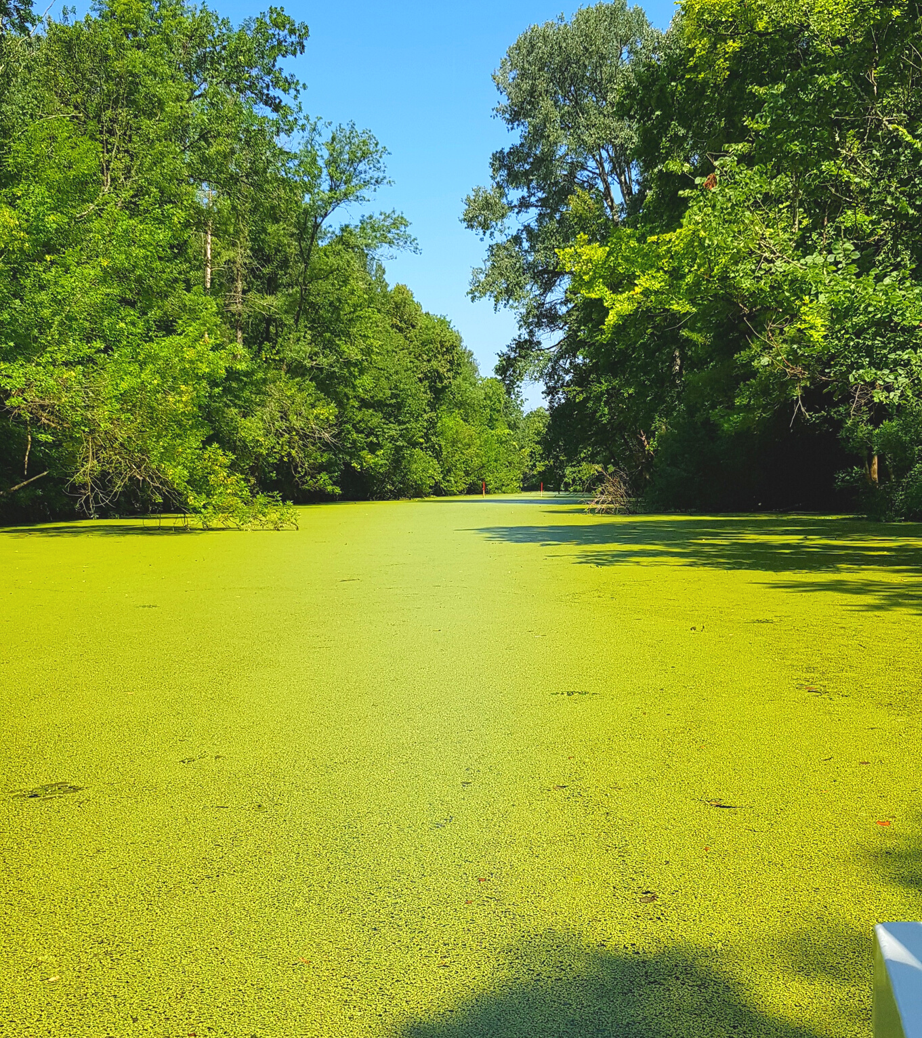
02
Itinerary

DAY 1: Transfer to Moslavina, into green undisturbed nature, an area of hilly vineyards with a beautiful view of Lonjsko polje.

DAY 2: Lonjsko polje Nature Park and its Krapje Reception Center is the starting point of an unforgettable ride in a tractor trailer to the neighboring village for a ride on solar-powered boats along the Struga, one of the calmest rivers in this area. You will stroll through beautiful nature and watch water birds in their natural environment. Krapje is a village specific for its wooden architectural heritage, of which our expert guides will tell you more. After Krapje, we continue our journey towards Čigoč, the first European stork village. There you will be greeted by the always cheerful hosts of “Tradicija Čigoč” with delicious carp. Did you know that a stork's nest weighs over a ton and that an adult stork gathers several kilograms of food for itself and its baby birds every day?

DAY 3: Hiking trails through the retention fields of the Lonjsko Polje Nature Park are a unique opportunity to see native breeds of domestic animals grazing and to listen to the story of our expert guide about the vast areas that serve as flood defenses in the winter months. Life here is easy and in harmony with nature. Next, we take you to the Repušnica Reception Center! Košćeva trail is a hiking trail only 5 km in length, following the northern embankment of the Lonjsko polje retention embankment along the floodplain meadows and pastures.
Native breeds graze freely here. Another option is organizing a cycling tour to the popular Jame canal where you can try your hand at kayaking.

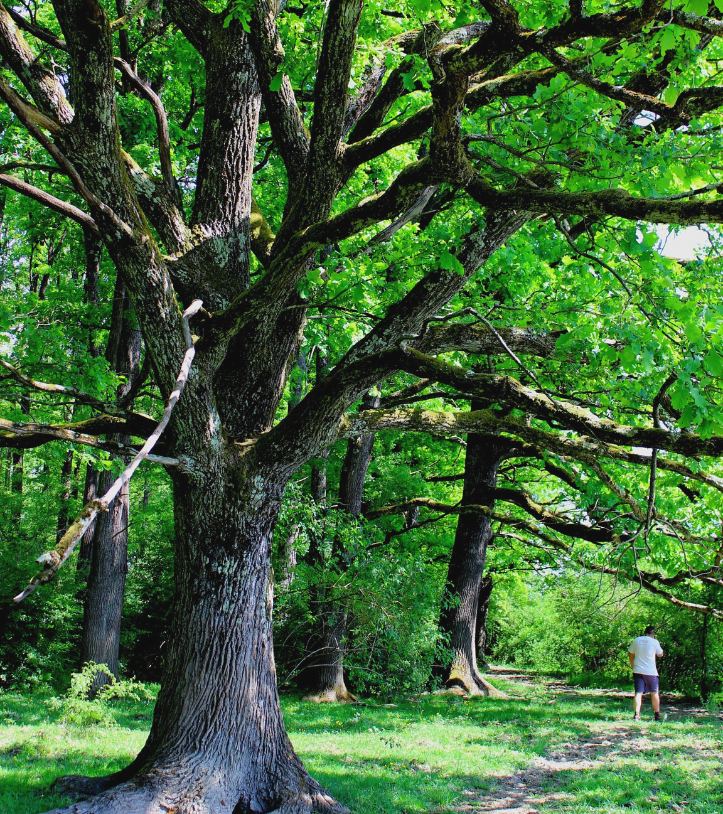
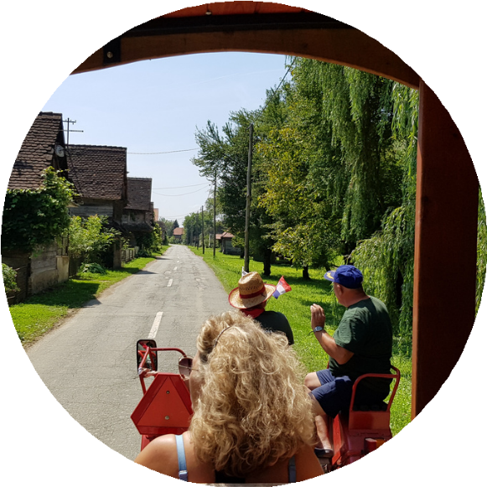
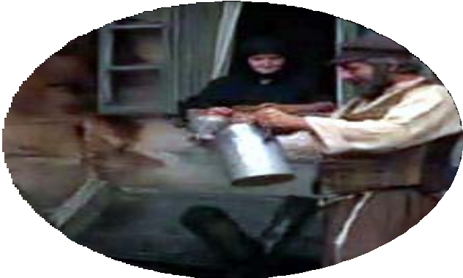
03

After Repušnica, we continue our journey towards Kutina to the Moslavina Museum, a rich gallery, cultural-historical, archeological and ethnographic exhibition, containing traditional clothing, jewelry, footwear, textiles, pottery, postcards, Easter eggs and much more... We will also walk along the beautiful Red Street that goes along the famous Moslavina porches to one of the most beautifully decorated sacral buildings in this area, the Church of St. Mary of the Snow.

DAY 4: You must have heard of the musical 'Fiddler on the Roof', and we are taking you to the village of Letovanić, where this film was shot. You will see the famous Škofač Ethnographic Collection and visit Kasajić family farm, where you can try horseback riding. The Letovanić area is filled with wooden houses and chapels that are characteristic of the Pokuplje region and which will surely delight you. We continue our journey towards a cactus nursery, where you will be able to buy a prickly souvenir as a reminder of this area. Then we take you to Pešćenica for lunch in the restaurant Turopoljska klet. A good drink comes after a good lunch, so a visit to Cestarić family farm to taste their famous "viljamovka" pear brandy and mead is the next stop.

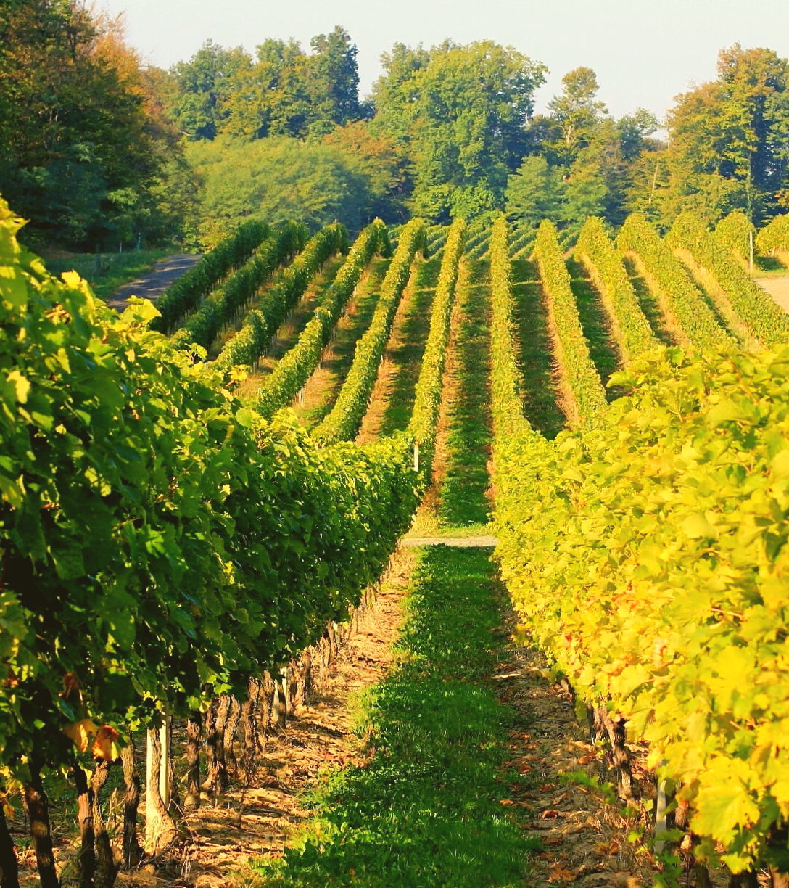
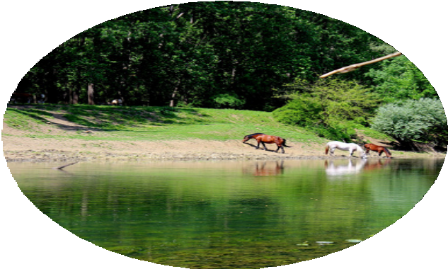
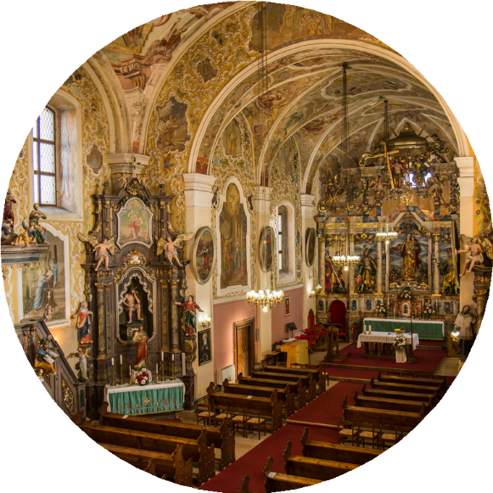

04
On the way back to Repušnica, we stop at Odransko polje, located along the Odra River, a perfect example of life in the past, with meadows full of flowers and horses grazing freely in the rays of the sun. This field is specific due to its size and the quantity of livestock and horses in this area, and it is part of a larger retention system of flood protection in Central Posavlje, which includes the areas of Lonjsko polje and Mokro polje. It belongs to two land units, the rural landscape of floodplain meadows and the complex of lowland oak forests, whose paths you will walk yourself.

DAY 5: Hilly Moslavina is a picturesque landscape with a long tradition of growing vines and where late spring brings the intoxicating scent of acacia flowers. A good drink and a view of the floodplains of the Nature Park is hedonism no person can resist. We have organized for you a visit to the famous wineries of the Moslavina region and wine tasting that includes the indigenous variety Škrlet. After a good drink, we continue our journey towards “Moslavačka priča” in Velika Ludina, an estate that brings you rural hedonism and an opportunity for a rest in nature, accompanied by a real Moslavina lunch. We leave the rest of the day free for walking and rest, as well as leisure activities on the property, which also offers sports facilities such as a tennis court, five-a-side football pitch, swing bowling and boating on the lake.

DAY 6: Transfer to the station

